# Exercises: Git and GitHub, Debugging and Troubleshooting

Problems for exercises and homework for the [“Programming Fundamentals” course @ SoftUni](https://softuni.bg/courses/programming-fundamentals).

## Upload a Few Projects at GitHub

Create a few **repositories** in your **GitHub** profile and **upload a few of your projects to GitHub**. These could be your **homework exercises** for the last few courses, your **teamwork projects** or any other projects that you might want to share with the developer community. Follow these steps:

1. First **create a local repository** for your existing project (folder in your hard disk). This will put your project under version control (in fact it will create a hidden folder named .git).

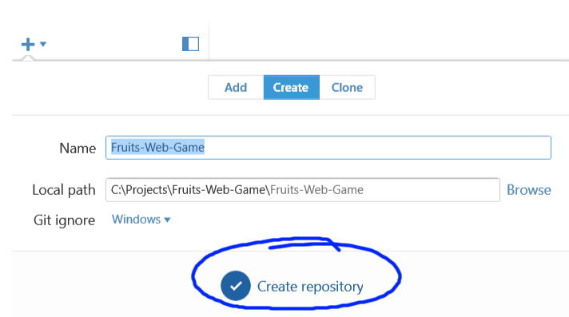

1. **Commit** your local files to your recently created local repository:

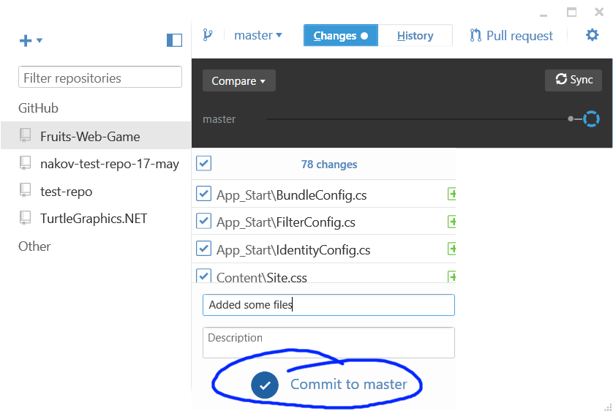

1. Then **publish** your local repository to GitHub:

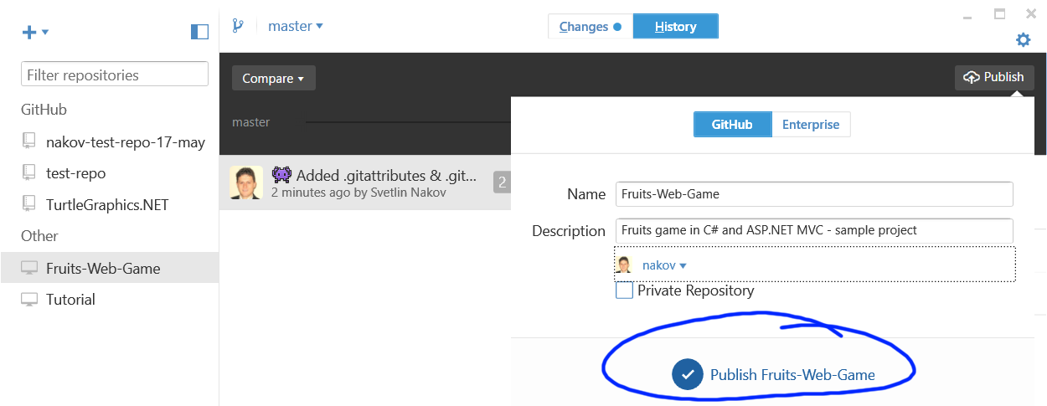

1. **Open your project at GitHub** to see whether is it really uploaded live on the Web:

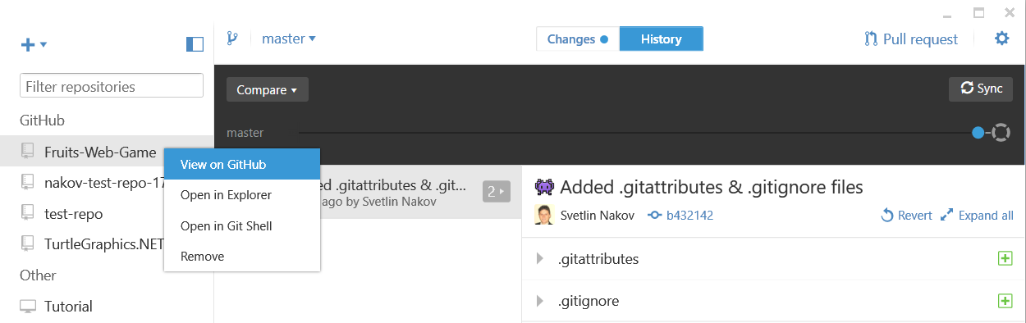

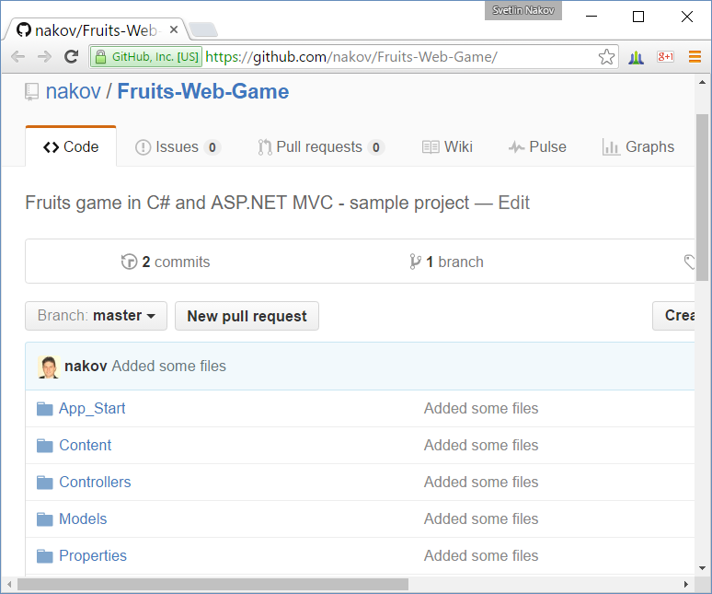

Note that all projects your upload at GitHub will be **open-sourced** and will be accessible for anyone in Internet, so be careful about passwords or code which you might not want to be visible by someone else.

## Play with Git: Clone, Change, Commit, Push

**Clone** some of your GitHub repositories through your **Git client** (e.g. using the **GitHub Desktop** software). Make some **changes** and **commit** them locally, then **push** them to GitHub. Check whether the changes are published in your GitHub profile in Internet. Follow these steps:

1. **Clone** an existing repository from your GitHub account into a **local folder** on your hard disk:

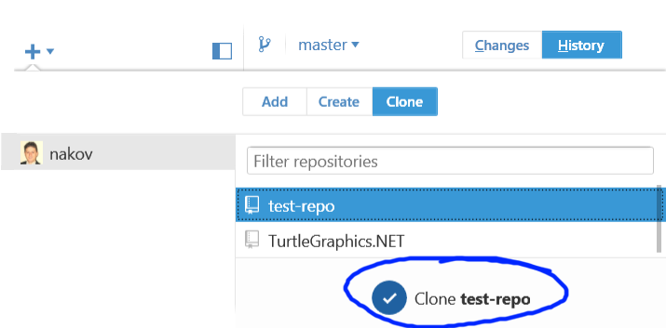

1. Open the project files in **Windows Explorer**.

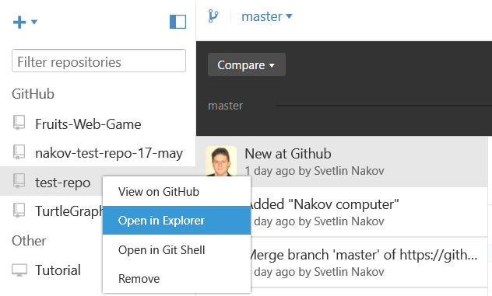

1. Make some **changes** in your favorite text editor:

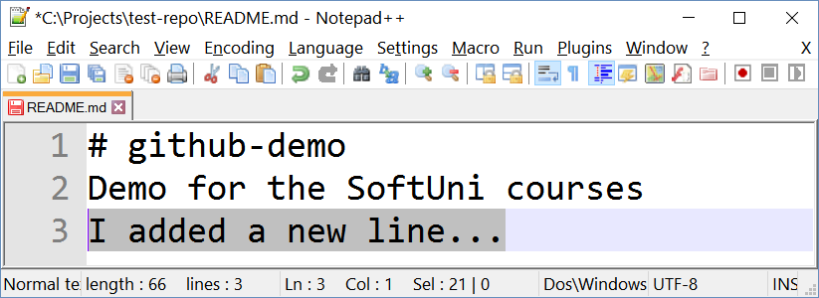

1. **Commit** your local changes to your local repository.

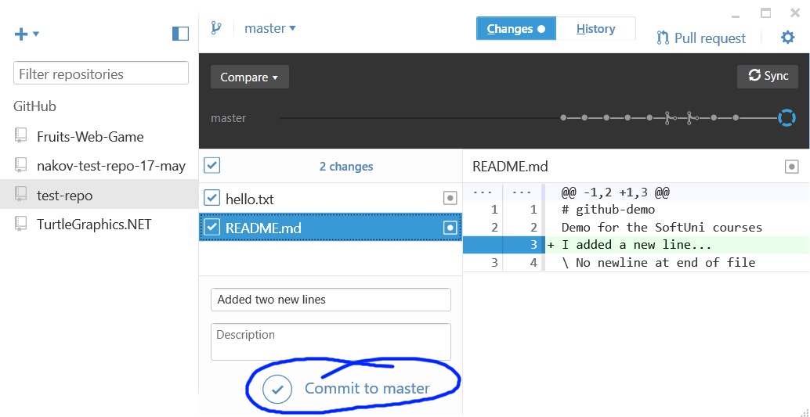

1. **Push** your changes to the remote repository in GitHub (use **Sync**):

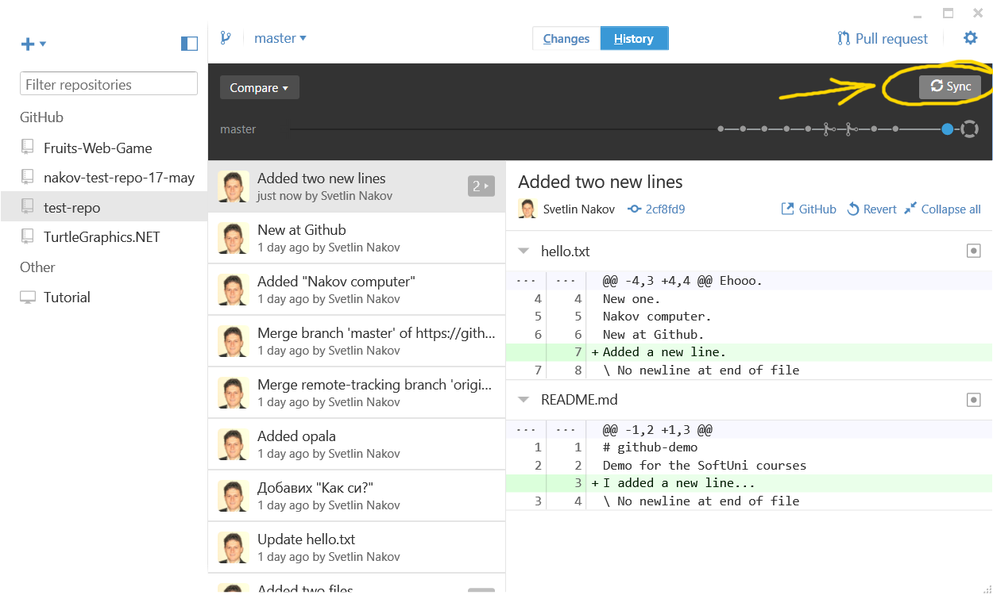

1. Check whether your changes are online:

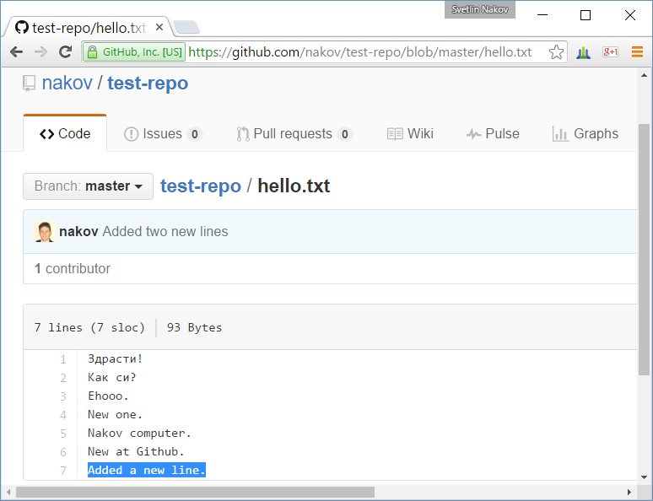

## Merge Conflicting Changes in GitHub

Create **conflicting changes** and **merge them**. Use the following steps:

1. **Clone a repository** from your GitHub account (if not already cloned). Use your favorite Git client software:

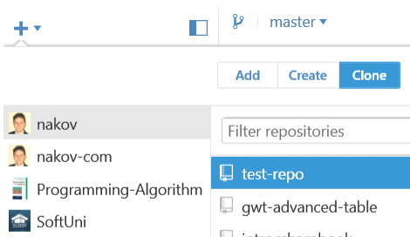

1. Make some **changes** in your working directory, e.g. edit the file README.md.

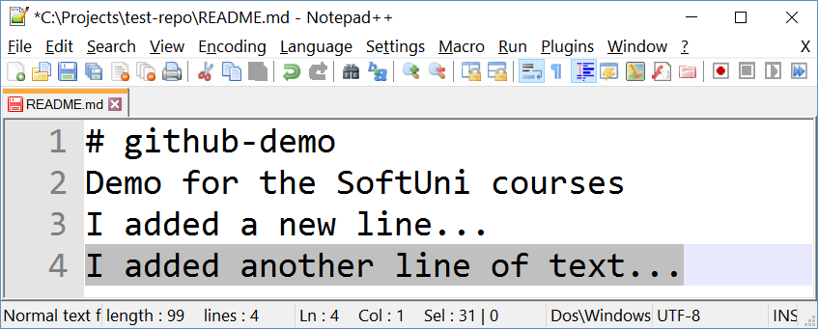

1. **Don’t comm**it and **don’t push** your changes yet.
2. Open your GitHub account from your **Web browser**. Make some changes online:

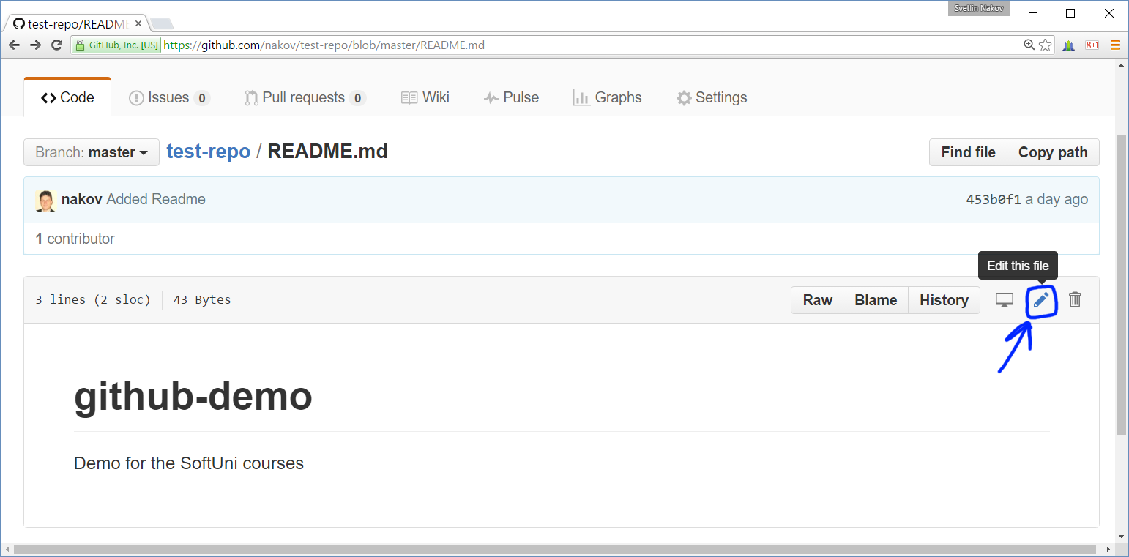

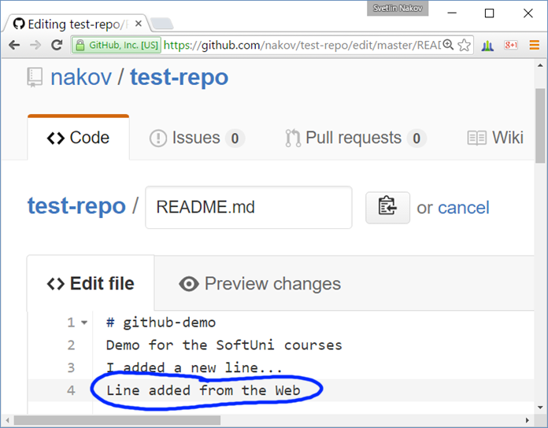

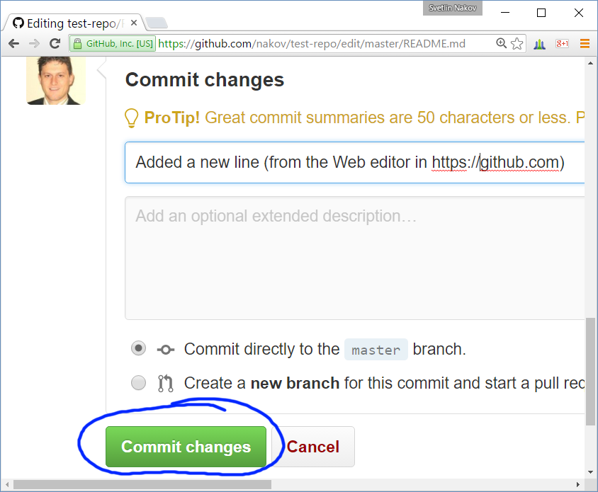

1. Now **commit** the local changes.

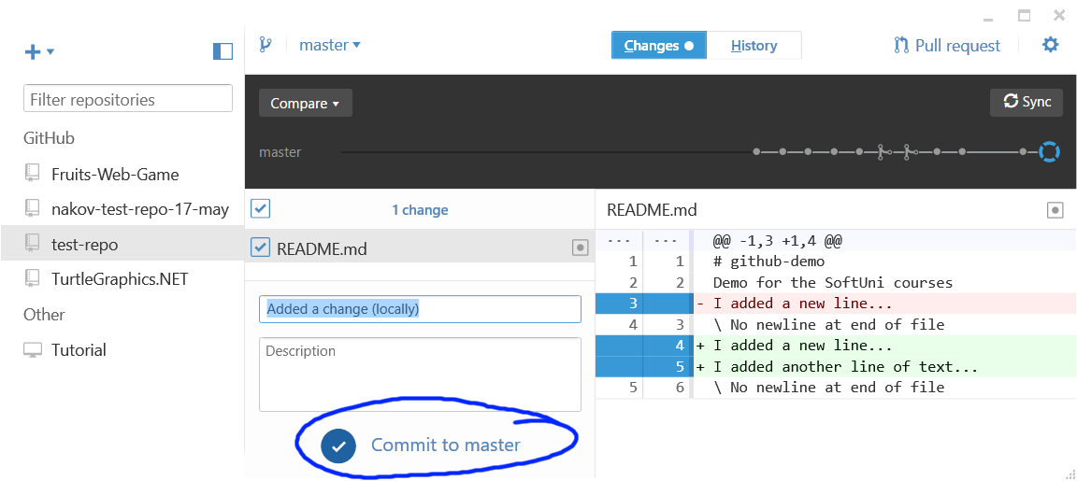

1. Try to **Sync** the local changes with the **remote repository** at GitHub:

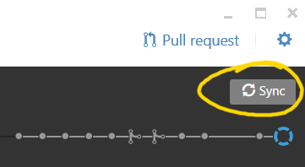

1. You will get **conflict notification**.

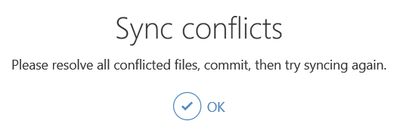

One of the files from the **local repository** will be **merged** with its newer version from the **remote repository**:

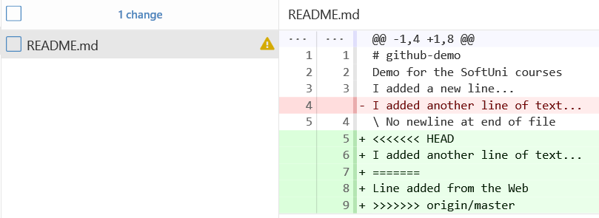

1. Now **resolve the conflict**. Edit the conflicting files and get then correctly merged. Remove all lines that point the locations of the merge conflicts (like <<<<<<< HEAD):

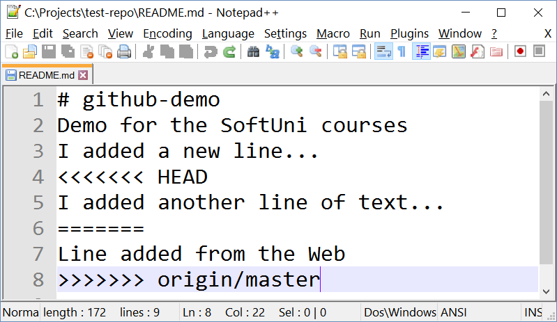 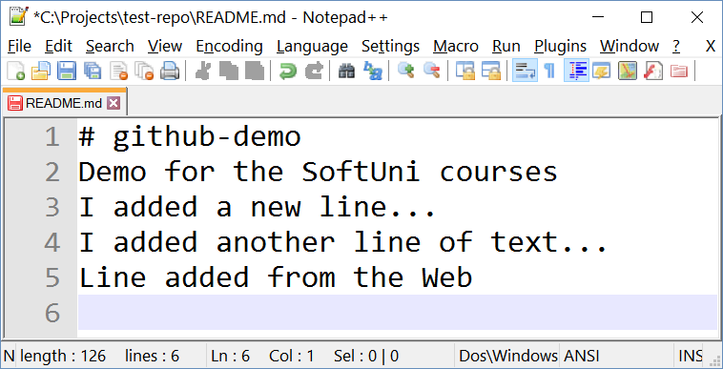

1. Now **commit the merged changes** (your local changes and your changed made from the Web):

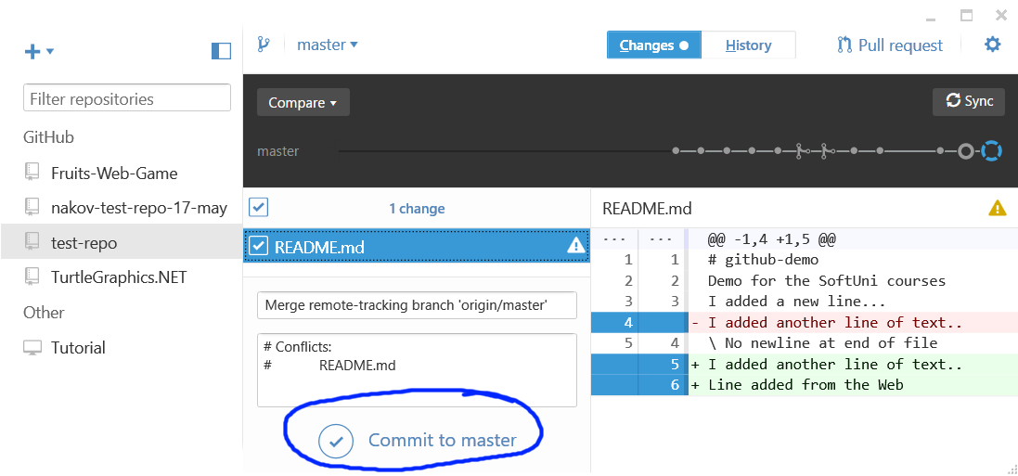

1. Now **sync again** to push your changes online to GitHub.

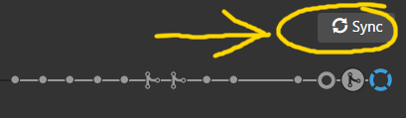

Now, the **sync should be successful** with **no conflicts**.

1. Finally, **check the changes** on the Web in your GitHub account:

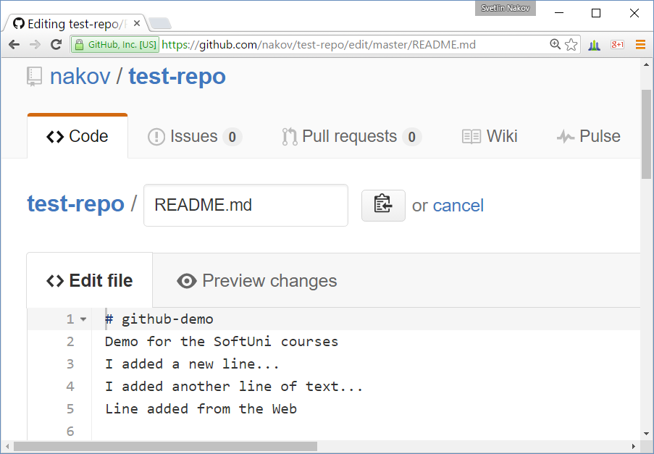

## Debugging Exercise: Instruction Set

Use the **problem description** and the **broken source code** from the judge: <https://judge.softuni.bg/Contests/203/Git-GitHub-Debugging-Searching-Exercises>. **Debug** the code and **fix** its bugs.

## Debugging Exercise: Be Positive

Use the **problem description** and the **broken source code** from the judge: <https://judge.softuni.bg/Contests/203/Git-GitHub-Debugging-Searching-Exercises>. **Debug** the code and **fix** its bugs.

## Debugging Exercise: Array Test

Use the **problem description** and the **broken source code** from the judge: <https://judge.softuni.bg/Contests/203/Git-GitHub-Debugging-Searching-Exercises>. **Debug** the code and **fix** its bugs.

## Debugging Exercise: Substring

Use the **problem description** and the **broken source code** from the judge: <https://judge.softuni.bg/Contests/203/Git-GitHub-Debugging-Searching-Exercises>. **Debug** the code and **fix** its bugs.

## Searching in Internet: Find a C# Trie Implementation

Find a **Trie data structure** implementation in **C#** in Internet.